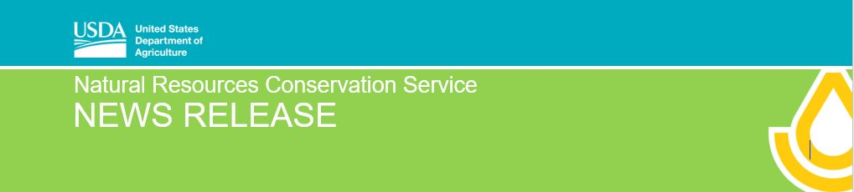
United States Department of Agriculture • Natural Resources Conservation Service • 2118 W. Park Court Champaign, IL 61821 • Phone: (217) 353-6600 • Web: www.nrcs.usda.gov/il
____________________________________________________________________________________________________________________________________
For Release: October 4, 2023 Contact: Dave Hiatt, NRCS 217-382-4123, Ext 115

NRCS Conservation Easements Available for Flood-Prone Illinois Lands in Alexander County

Champaign, October 4, 2023 –USDA’s Natural Resources Conservation Service (NRCS), Illinois will be holding a final sign-up period for the Floodplain Easement component of the Emergency Watershed Protection Program (EWPP-FPE). Landowners impacted by flooding from the breach of the Len Small Levee in 2016 and subsequent flooding from additional years are encouraged to apply.

According to State Conservationist Tammy Willis, “We have some landowners and farmers in the Dogtooth Bend area that may not have been able to apply in a previous sign-up period or other landowners who initially were not eligible to apply. We want to make sure that we are providing consistent and equitable program delivery to all persons impacted by the persistent flooding. By using EWPP-FPE funding, we can offer an easement alternative for them to consider.” Illinois funding targets Alexander County’s southern tip, known as Dog Tooth Bend. The area exists where the Mississippi River meanders around Illinois and meets up with the Ohio River, often leaving no place for rising floodwaters to go.

Landowners in Dog Tooth Bend will have access to federal financial assistance. Individuals must sign up for the EWPP-FPE October 16th– October 27th, 2023.

The EWPP-FPE program is a voluntary program through which eligible applicants agree to sell a permanent conservation easement to the United States through NRCS. Compensation is based on the value of the easement as determined by an appraisal or market analysis. These easements may occur on public or private agricultural land or residential properties damaged by flooding and natural disasters. NRCS will work to restore the easement to its natural floodplain condition.

Property owners interested in applying for EWPP-FPE can review program information on the Floodplain Easement webpage. More information about the EWPP-FPE can be obtained from your local USDA NRCS Field Office or visit www.nrcs.usda.gov/il.
Helping People Help the Land.
USDA is an equal opportunity provider, employer and lender.

